НУРБАЕВА Баян Ертаевна,
«Al Farabi Bilim» мектебінің ағылшын тілі пәні мұғалімі.
Шымкент қаласы

BLENDED LEARNING IN TEACHING ENGLISH: COMBINING ONLINE AND OFFLINE METHODS
In recent years, the integration of digital technologies into education has led to the development of blended learning models. This article explores how blended learning can be effectively used in English language teaching by combining traditional face-to-face methods with modern online tools. It presents the benefits, challenges, and practical applications of this approach in the context of secondary education in Kazakhstan.
The 21st-century classroom is rapidly evolving, with technology playing a pivotal role in reshaping how students learn and teachers instruct. Traditional classroom teaching, while still valuable, is no longer sufficient to meet the diverse needs and learning styles of students. This has given rise to blended learning — a model that merges face-to-face instruction with digital platforms, offering flexibility, personalization, and enhanced engagement.
In the context of teaching English, blended learning provides opportunities for learners to interact with language materials both in and outside the classroom. This article aims to examine the concept of blended learning, its relevance in English language education, and practical ways to implement it effectively.
What is Blended Learning?
Blended learning, also known as hybrid learning, refers to the combination of traditional classroom methods with online learning activities and digital media. It allows students to learn partially through teacher-led instruction and partially through digital content accessed via the internet.
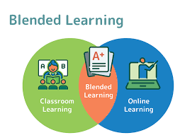
There are several models of blended learning, including:
- Rotation model – students rotate between different learning stations (online and offline).
- Flex model – online learning is the core method, with teachers providing support when needed.
- Enriched virtual model – students complete most learning online but attend in-person sessions periodically.
In English teaching, this might involve using online platforms for grammar exercises, videos for listening practice, and forums for discussion, while still engaging in in-class speaking and writing activities.
Benefits of Blended Learning in English Teaching
- Flexibility and Accessibility
Blended learning allows students to access materials at their own pace and time. This is especially useful for revising grammar rules, practicing vocabulary, or listening to audio materials multiple times.
- Personalized Learning
Online tools often include adaptive features that tailor tasks to individual learners' levels. Teachers can assign different tasks based on student performance, making learning more effective and inclusive.
- Enhanced Student Engagement
Digital platforms such as Kahoot, Quizlet, Edmodo, and Google Classroom offer interactive activities that make language learning more enjoyable. Videos, podcasts, and online quizzes can make lessons more dynamic.
- Improved Collaboration and Communication
Blended learning encourages collaboration through discussion boards, peer feedback on writing tasks, and group projects conducted online.
- Continuous Assessment
Teachers can track students’ progress in real-time through learning management systems (LMS). Online quizzes and assignments provide instant feedback, which helps identify areas for improvement.
Challenges in Implementing Blended Learning
Despite its advantages, blended learning is not without challenges:
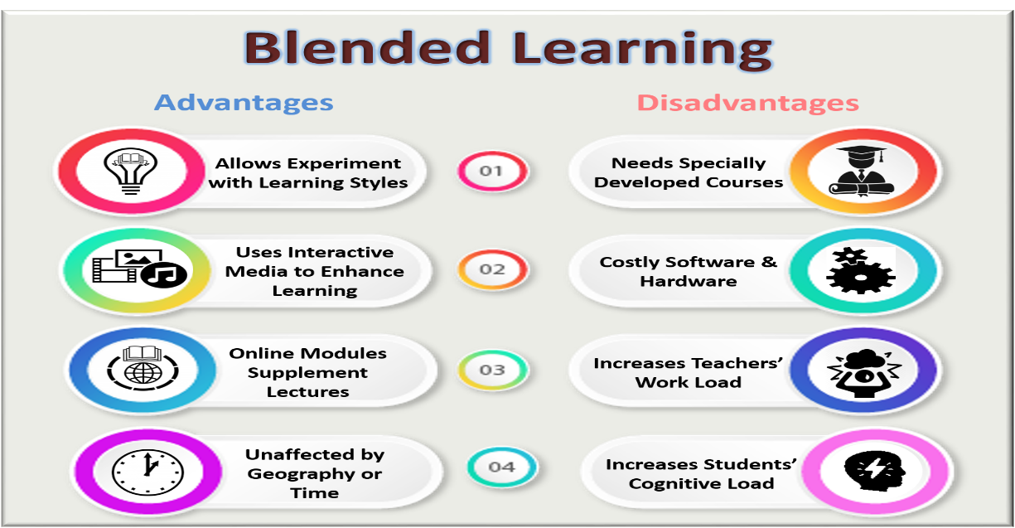
- Lack of Access to Technology
Not all students have reliable internet access or personal devices at home, which can create inequality in learning opportunities.
- Digital Literacy
Both students and teachers need training to effectively use digital tools. Without proper skills, technology can become a barrier rather than a facilitator.
- Time Management
Preparing blended lessons takes more time than traditional ones. Teachers need to carefully plan which content is best delivered online versus in person.
- Student Motivation
Some students may struggle with self-discipline when learning online. Without direct supervision, they may not complete assignments or stay engaged.
Blended Learning in Practice: Case Study from "Al-Farabi Bilim" School
At "Al-Farabi Bilim" school, blended learning has been actively implemented since 2022. English teachers use Google Classroom to share homework, reading materials, and video lessons. In-class time is dedicated to communication activities, group discussions, and project-based tasks.
For example, during a unit on environmental issues, students watched a documentary at home and participated in a classroom debate the next day. Grammar practice was assigned through interactive quizzes on Quizizz, allowing students to practice at their own level and pace.
This approach has shown positive results — students are more motivated, autonomous, and confident in using English for communication.
Practical Tips for Teachers
- Start Simple
Use one or two platforms that are easy to navigate. For example, Google Forms for quizzes or Padlet for brainstorming ideas.
- Balance Online and Offline Tasks
Ensure that digital tasks complement in-class activities. Don’t overload students with too much online work.
- Provide Clear Instructions
Students should know exactly what is expected in both online and offline components of the lesson.
- Encourage Feedback and Reflection
Ask students to reflect on what they learned online and discuss it in class. Peer feedback can also be encouraged on writing tasks.
- Monitor Progress
Use LMS analytics to track student engagement and identify those who need additional support.
Blended learning is more than just a trend — it is a powerful educational approach that meets the needs of modern learners. By combining the strengths of traditional teaching with the advantages of digital tools, English language teachers can create rich, engaging, and effective learning environments.
While challenges exist, with thoughtful planning and support, blended learning can transform the way English is taught and learned in schools like "Al-Farabi Bilim". The key is to maintain balance, ensure accessibility, and keep students actively engaged throughout their language learning journey.

